Institute of Technology Tralee
Computing Department

Object Oriented Programming 1
__________________________________________________

Problem Solving 5 – Loops and Input Validation

Q1.

- A Java program is required that will read in some of the details of an arbitrary number of animals at a zoo, using a while loop. The details to be read in are the animals’ name, weight and date of birth. You can take it here that the weight value can have a fractional part and that the date of birth must be entered in the form dd/mm/yyyy. No validation is required at this stage, however. Your loop will terminate when the user enters the empty string for the name. When the loop finishes, the details of the animals entered will be displayed neatly aligned in a text-area as indicated in the following screenshots:

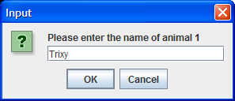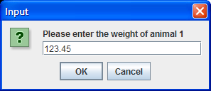
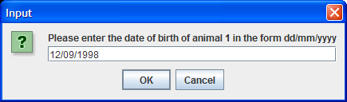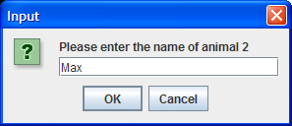
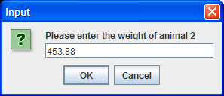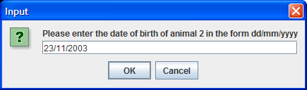
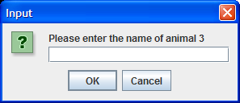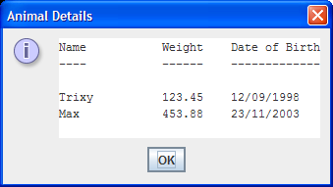

- You should now add to the code from part(a) so that the program will keep track of all the details of the lightest and heaviest animals. When the loop has finished, these additional details should also get displayed in the text area as indicated in the following screenshot – note that these additional details are not formatted in any special way.

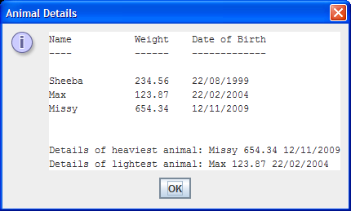

- Your program should now add to the code from part(b) so that the weight range is determined. This value is simply the difference between the heaviest and lightest animal weights. This functionality should be carried out through a user-defined method called weightRange(), which will take 2 arguments – these being the largest and smallest weight values entered – and the method should simply return to main() the difference between the largest and the smallest weight values. This additional piece of information then gets displayed to the nearest whole number in the text area, as indicated below:

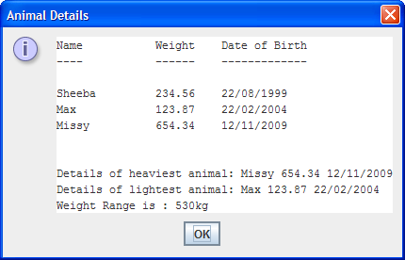

- You should now add to your program from part(c) so that the date of birth is validated for each animal and, if an invalid value is supplied, the validation loop must re-iterate until valid input is supplied. A valid date of birth will contain exactly 10 characters, with the 3rd and 6th characters forward slashes and the rest all digits. You do not need to worry about validating the day values at all (except for the fact that they must be integer values in the range 1-31) e.g. the date 31/02/2010 will be considered valid even though there cannot be more than 29 days in February. The month value must be in the range 1-12 and the year must be between 1900 and 2014 inclusive.

Your program will now run as indicated in the following sample screenshots:

1st iteration of the main loop:
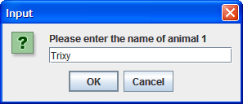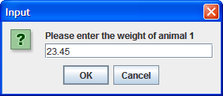

supplying an invalid date of birth … the validation loop keeps reiterating
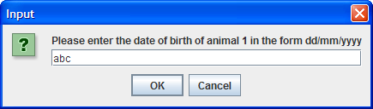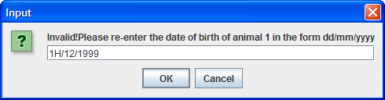
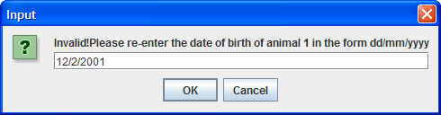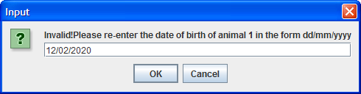
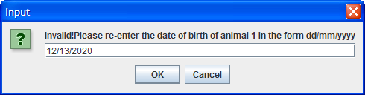

…. Until a valid value is supplied

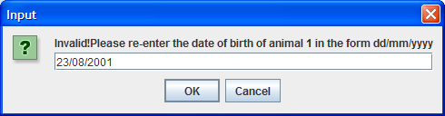

Once the validation loop quits, the main loop does some processing and then proceeds to read in the details of the next animal:

